Core|PAY: AE Re-enrolment

Contents
Document Version Control 1
Approved process for raising 2
Consultation & Approval 2
Change Management 2
How to 2
Testing 2
Communications 2
Downstream Systems & Processes 2
Affected Reports 2
Additional Background Information 2

Document Version Control
Change History/Review Details
Date | Version | Review by | Summary of Change
3 May 2022 | 1.0 | HC | Created

Approved process for raising
Does the change need to be raised through a particular route or by a particular person/team? Are there any actions which need to be taken or considered prior to processing in the HRIS Support Centre?
As the owners of this process the Pensions team should contact us about testing and implementing this process at the appropriate time. However, it is usually the case that we contact them.

Consultation & Approval
Who is the owner of this information? Who needs to be consulted about this change before you begin work on it? Does anyone need to approve this change before it is implemented?
This is a legislative requirement that is carried out every three years. All employees who have not been enrolled onto a Pension scheme in the last 12 months will be automatically re-enrolled into a relevant pension scheme (OSPS, USS, NEST, NHS) according to their contract type and grade.
The Pensions team will contact the affected employees in advance to let them know that they will be re-enrolled.
Testing will be completed in collaboration with the Payroll team and agreement will need to be reached about when the testing can take place.

Change Management
What type of change is this? When should approval be sought and from whom (internal to team or change manager)? Who would normally be responsible for implementing?
The change process applicable at the time of the change should be followed. The current process is to create a change request in OSM which is approved by the relevant approver.
The HR Functional Analysts are responsible for testing the re-enrolment process in collaboration with the Payroll team.
This process may be a candidate for a Standard Change as we do not configure the system, the re-enrolment periods are updated automatically.

How to
Technically how to process the change in the system
Adding a new ….
Navigate to: Not applicable

Changing a ….
Navigate to: Payroll Dashboard>UK Tax Rates>General>Maintain Statutory Pay Parameters

Select 'Auto-Enrolment' and then choose 'Pay Groups'.

Removing a ….
Navigate to: Not applicable

Standard Icons & Terminology
Standard Button Names  Enter Query Mode button:  Previous Record button:   Previous Section button:   Save button:   Insert Record button:  | Execute Query button:   Next Record button:   Next Section button:   LOV button:   Delete Record button:  | Cancel Query button:   Red Door button:   Duplicate Record button: 
Navigation Paths

Show the final navigation path option in bold+italics, for example;

Core|Personnel > Reference > Reference A – C > Accident Codes
Core|Pay > Reference > Pay Groups

Any further navigation beyond the navigation path can be added after an ellipsis (…), for example;

Event Management > Event Configuration … HR Events > Change of Address

Other Standard Terminology

Testing
Who would normally be responsible for testing? Are there standard items to test?
Testing will be completed by HR Functional Analysts in collaboration with the Payroll team and agreement will need to be reached about when the testing can take place.

There are three standard scenarios that need to be tested:

Scenario | Expected results
- Opted out more than 12 months ago  (If Casual > £833 earned in June) | Auto-enrolled
2. Opted out and contractually re-enrolled | Not reassessed as now contractually enrolled
3. Opted out less than 12 months ago | Not re-assessed

Examples should be identified and screenshots taken after the May payroll has been run to check that the employees were not enrolled in May. From the Payroll Dashboard, search for and open the employee record and then go to Additional > Pension

To assist in identifying suitable examples an SQL report called 'Employees who have opted out of a Pension scheme' is saved in P:\PROJECTS\HRIS Programme\12. Support\Reports\SQL and RDL Library\Functional Analyst SQL Depository

Once the June payroll has been run, the records should be viewed again and screenshots taken.

Communications
Who needs to be informed (but not consulted) about this change? Detail when they should be informed (before or after the change).
The Pensions team will contact the affected employees in advance to let them know that they will be re-enrolled.

Downstream Systems & Processes
Details of any processes which are affected or need to be carried out following, or as part of, the change. Please detail any triggers, actions required and when the actions should be carried out.
None identified

Affected Reports
Are there any standard reports which may need to be updated following this change?
No reports should be affected by the change but PERPEN15 is used to identify employees who are due to be re-enrolled.

Additional Background Information
Any other relevant information, links to supporting documentation etc.
Auto Enrolment re-enrolment is a legislative process that must be carried out every three years. Further details can be found on the Pensions Regulator website - https://www.thepensionsregulator.gov.uk/en/employers/re-enrolment

For the main University, the exercise is carried out in June and previous exercises have been carried out in 2016, 2019 and 2022. The next exercise is due in June 2025.

For Linacre College the exercise is carried out a year later and in July. Previous exercises were completed in 2017 and 2020. The next exercise is due in July 2023.

The Re-Enrolment period is set against the relevant Pay groups (20 and 21 for the main University and 60 for Linacre). This will be updated automatically once the latest exercise is completed but it is always worth checking that the periods have been updated as expected.

To check the settings navigate to:- Payroll Dashboard > UK Tax Rates > General > Maintain Statutory Pay Parameters. Select 'Auto-Enrolment' and then choose 'Pay Groups'.

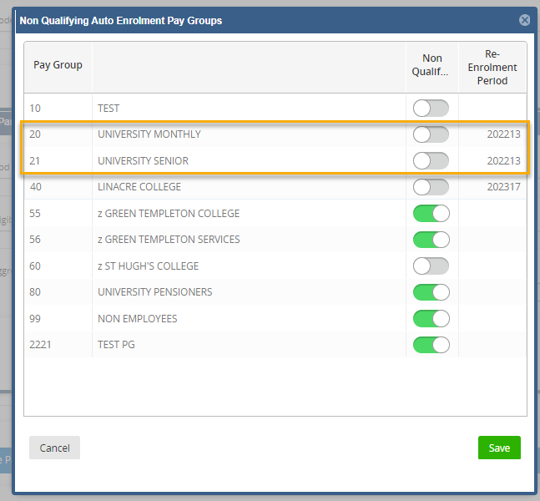

In 2019 the Pensions team administrator (Linda Howse) provided the following steps and confirmed in 2022 that nothing needed to change:

Changes since last exercise
- On re-enrolment we will exclude those who opted out in previous 12 months.
- We will exclude those who have Fixed Protection, provided we are aware of the individuals.
- Check that there were no other changes since last exercise

Suggested process (Pensions team unless exceptions noted)
- Re-enrolment date - 1 June.
- Identify eligible staff – work needed to check excluded groups – directors, proctors etc.
- Write to eligible staff - We need to identify and contact (via email) those we plan to re-enrol 6 weeks prior to re-enrolment.
- We plan to use the same approach as 2016, to give notice early June to USS members only who may be opted in and process as many opt outs as possible prior to payroll cut off. For OSPS members, they must be enrolled and opt out via L&G.
- Declaration of compliance – to be submitted to the Pensions Regulator by end of July.

Actions needed (Pensions team unless exceptions noted)
- Agree approach – payroll, HR and pensions
- Inform subsidiaries and other employers (OUEM, SBS, Oxford Ltd, Student Union etc.)
- Inform Linacre – check date
- Confirm if PXD will exclude those who opted out in previous 12 months (HR Systems team testing)
- Update website material e.g. remove slide pack, update limits
- Agree what internal comms are required, and if comms required for particular groups (e.g. Marie Curie)

Summary (Pensions team unless exceptions noted)
- Marie Curie fellows to be excluded
- Those known to have fixed protection to be excluded. Also those who said they had given notice to leave

